### A PROJECT REPORT

### ON

**Online Dictionary**

**Submitted To**

SSJ IT Solutions Private Limited

**Submitted By**

Ritik Singh

Anand Gupta

Prakhar Gupta

Suryansh Tiwari

Swarn Pallav Bhaskar

**Under the Supervision of**

Mr. Kushagra Srivastava

**Date of Submission**

May 17, 2021

**Abstract**

I the undersigned solemnly declare that the project report **“Online Dictionary”** is based on our team work carried out during the course of our internship under the mentorship of **Srivastava**.

I assert the statements made and conclusions drawn are an outcome of my research work I further certify that

1. The work contained in the report is original and has been done by me under the general supervision of my supervisor.
2. The work has not been submitted to any other Institution for any other degree/diploma/certificate in this university or any other University of India or abroad.
3. We have followed the guidelines provided by the university in writing the report.
4. Whenever we have used materials (data, theoretical analysis, and text) from other sources, we have given due credit to them in the text of the report and giving their details in the references.

**Team Members**

Swarn Pallav Bhaskar

Suryansh Tiwari

Ritik Singh

Prakhar Gupta

Anand Gupta

Date: May 14, 2021

## Certificate

This is to certify that the Project report entitled **“Online Dictionary”** doneby **Swarn Pallav Bhaskar, Suryansh Tiwari** and **Ritik Singh, Prakhar Gupta, Anand Gupta** is an original work carried out by them under my guidance. The matter embodied in this project work has not been submitted earlier for the award of any degree or diploma to the best of my knowledge and belief.

Date:

##### Mr. Kushagra Srivastava

**Signature of the Mentor**

**Acknowledgement**

The merciful guidance bestowed to us by the almighty made us stick out this project to a successful end. We humbly pray with sincere heart for his guidance to continue forever.

We pay thanks to our project guide Mr. Kushagra Srivastava who has given guidance and light to us during this project. His versatile knowledge has cased us in the critical times during the span of this project.

We pay special thanks to **Mr. Suraj Jaiswal,** founder of **SSJ IT** **Solutions Private Limited**, who has been always present as a support and help us in all possible way during this project.

We also take this opportunity to express our gratitude to all those people who have been directly and indirectly with us during the completion of the project.

We want to thanks our friends who have always encouraged us during this project.

At the last but not least thanks to all the mentors of **SSJ IT Solutions** **Private Limited** who provided valuable suggestions during the period of project.

## Abstract

With the increasing number of credit card applications, banks are opting towards the use of prediction-based algorithms as opposed to manual approval methods. Data analysis has exhibited a strong correlation between several financial and personal factors of a client and the likelihood of said client complying with their respective bank's credit policies. In this paper, we propose the use of the PARAFAC tensor factorization method to predict and grant credit cards to applicants based on the customers' activity history. We used six financial and personal factors and constructed a tensor by reducing them into three factors. We predicted the resulting factors through the use of alternating least squares algorithm with an emphasis on error minimization and finally re-constructed the original tensor. Using this tensor factorization, the machine-learned which of these applicants are most likely to accumulate bad debts and granted or rejected the applications based on the prediction.

Mostly this credit cards issued by local area banks the size of credit card is specified by ISO/IEC 7810 standard with 85.60*53.98mm in size.

The credit card was first used in the united states of America in 1920s. credit cards are issued by banks after the consumer opens the bank account and requested for the card. The credit card is have their personal identification number (PIN) for payment by signing a receipt with card details electronic verification system allow to verify the credit card validity and customer should maintain sufficient amount of credit in his account then only he can have accessing permissions. Credit card processing is very efficient when compared to other cards.

#### TABLE OF CONTENT

Declaration............................................................................................................................ 2

Certificate ...................................................................................................................... 3

Acknowledgement .............................................................................................................. 4

Abstract ..................................................................................................................... 5

Table of Content................................................................................................................... 6

List of Figures …………………………………………………………………………….. 7

**Chapter 1. Introduction ............................................................................................…. 8**

**Chapter 2. Literature Survey………………………………………………………… .9**

2.1 Web Dictionaries ……………………………………………………………9

2.2 Dictionary Apps ………....………………………………………………….9

2.3 Breakthrough………………………………………………………………..10

**Chapter 3. Problem Formulation……………………………………………………...11**

3.1 Addiction to Dictionary Usage……………………………………………...11

3.2 The User Interface façade…………………………………………………...11

3.3 Processing Speed……………………………………………………………11

3.4 Web of Internet Rapido……………………………………………………...12

**Chapter 4. System Analysis & Design…………………………………………………13**

4.1 Flowchart…………………………………………………………………....13

4.2 Module Used…….……………………………………………………..........14

4.3 What is JSON?................................................................................................14

4.4 What is difflib?................................................................................................14

**Chapter 5. Implementation………………………………………………………..........15**

**Chapter 6. Result & Discussion………………………………………………………...16**

6.1 CASE 1: - If exact word is present in dictionary …………............................16

6.2 CASE 2: -If suggested word is present in dictionary…………………..........16

6.3 CASE 3: -If none of the suggested words are present in the dictionary..........17

**Chapter 7. Conclusion, Limitation & Future Scope………………………………...18**

**References……………………………………………………...19**

**LIST OF FIGURES**

**Page No.**

|  |  |
| --- | --- |
| **Figure 4.1** | **13** |
| **Figure 6.1** | **16** |
| **Figure 6.2** | **16** |
| **Figure 6.3** | **17** |

# Chapter 1

## Introduction

Dictionary is a book or electronic resource that lists the words of a language (typically in alphabetical order) and gives their meaning, or gives the equivalent words in a different language, often also providing information about pronunciation, origin, and usage.

Compared with paper dictionaries that mainly organize entries around a single word, online dictionaries allow users to access multi-words by consulting more than one component of a multi-word. Thus, users can search for a certain verb phrase as a whole to identify its meaning.

Together with the multifunction provided by online dictionaries, dictionary users can learn more about the latest revisions and new words as editors can update entry information every few months

* A dictionary can be used to look up the **meaning** of a word.
* You can also use a dictionary to check the **spelling** of a word.

Today, as a novice software developer, we are going to present our first internship project before you. We designed an online dictionary. Python has been used for our project since it is interpreted and dynamic. While studying and working in different levels, we frequently come across inconveniences with English vocabulary. So, we thought of designing a software which is user friendly and flexible**.**

# Chapter 2

## Literature Survey

Since the development of world wide web, finding the meaning of word has evolved from using offline dictionaries to online one.

**2.1 Web Dictionaries-**

There are several sites which provide word-meanings like American Heritage Dictionary, Collins Online Dictionary, Dictionary.com, Merriam Webster Online, Oxford Dictionaries Online etc.

These dictionaries not only provide the meaning of the word but also additional information related to it like how to pronounce the word. The problem that arises is sometimes it gets difficult for an Indian user to search an English word of Indian origin, it also gets difficult for them to understand western user interfaces of these websites.

**2.2 Dictionary Apps-**

Not only websites but there are applications also Indian too but the problem with them is still unresolved.

Indian Dictionaries like Hindkhoj, Shabdkosh are an effort in this direction of making online dictionaries accessible to Indian audience still they have several issues in them like processing speed, friendly U/I.

With time dictionaries have evolved in their area of use i.e. earlier it use to be only about word and a meaning but now it has revolutionalised the era with addition of Synonyms, Antonyms, Word of the Day, Word within the sentence etc.

Most of these dictionaries have premium packs other than the free segment which has additional features and costs several hundred to users.

Costing hundreds of rupees to millions of users without proving them equivalent resources is a problem with them.

Some of these apps need network connectivity for features like word of the day.

Most of these apps don’t use traditional techniques for there functioning hence are less efficient. For progressing word like todays using efficient techniques has become necessity to work smarter than the old age concept of working hard.

**2.3 Breakthrough-**

Our dictionary is based on python model which is programmed with words and their meanings, there are a lot of words fed to it and always has a scope of improvement but still it will be best available because of it’s wide dataset.

The other part that makes it stand with an extra edge is the user interface in which it will be programmed. User Interface will be made using Tkinter Library of python which will make it easy for Indian users to access it.

# Chapter 3

## Problem Formulation

**3.1 Addiction to Dictionary Usage-**

The main purpose behind use of dictionary has been left far behind which was to increase people’s vocabulary only and not to make them dependent on dictionaries.

But today’s dictionaries use such approach which is making people more and more dependent on it.

It will be better if people learn comprehending meaning of new words without seeking dictionaries.

Our dictionary doesn’t serve users everything but supports them in understanding how to formulate meaning to new words which is on the idea of making users independent.

**3.2 The User Interface façade-**

20/30 apps downloaded don’t have proper user interface to satisfy user interest and make it easy even for a newbie to learn new words.

The Tkinter Approach towards developing the GUI is best to simplify it for the customers as it has various widgets like combo box, check button, labels, window etc.

If we shed light on dictionaries in early 2000, the problem was also with the U/I in addition to processing speed, data which used to develop ambiguity in users.

But the time has changed & therefore there’s a valid need for better versions of our old works.

**3.3 Processing Speed-**

With good database arises the question - **Whether the processing speed will go** **unaffected?**

The answer is a clear no most of the times, reason being the algorithm used to develop the dictionary, even offline dictionaries are slow in the processing i.e. when it’s not about the internet speed.

So, our dictionary has used best possible optimization to surpass such problems and is performing better than others.

**3.4 Web of Internet Rapido-**

The dictionaries which use www for their additional features make it difficult for people living in remote areas to have access to add-ons like Word of The Day, Topic of the Day etc.

We can easily program it in our model to work offline with only a small requirement of an update after several months.

As 67% of Indian population lives in rural areas where it’s difficult to have streamline access to internet.

# Chapter 4

## System Analysis & Design

**4.1 Flowchart: -**

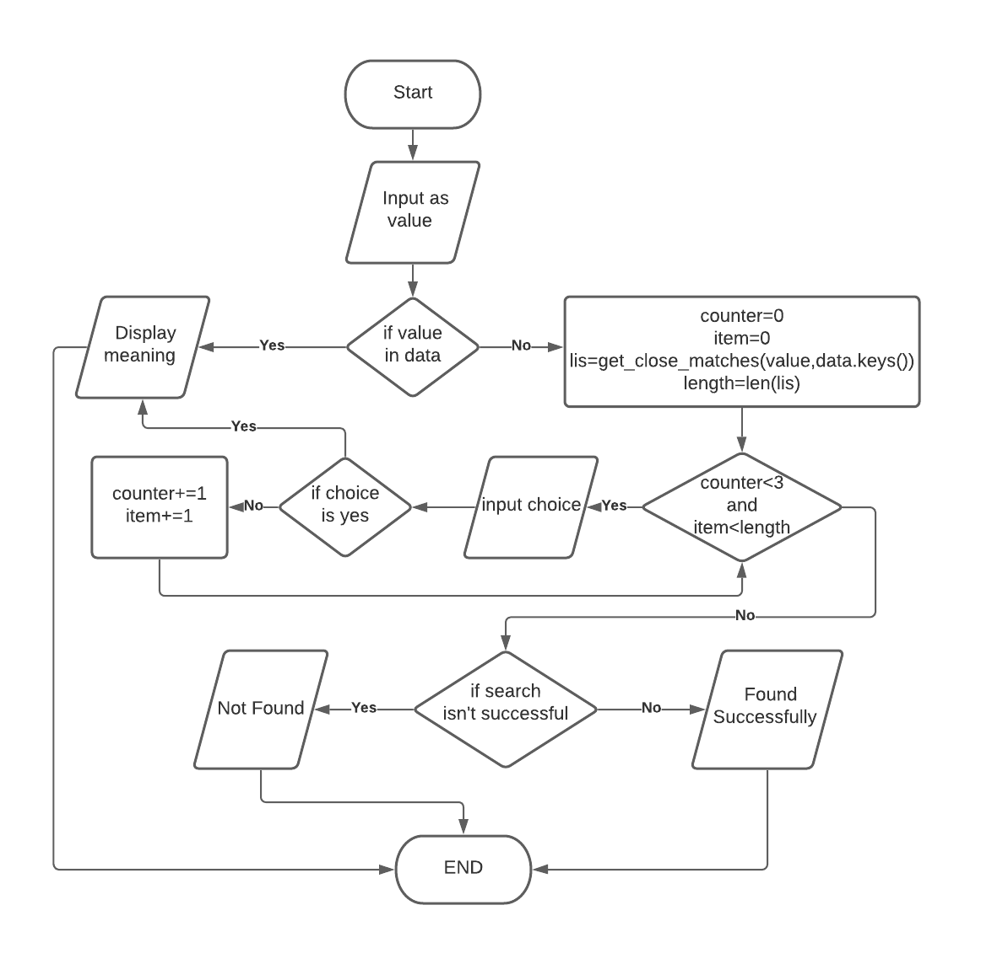

Fig 4.1

**4.2 Module used:**

In this script, we will use the JSON module because we will use a JSON file and loading requires the JSON module. We will use difflib module.

**4.3 What is JSON?**

JSON (JavaScript Object Notation) is an inbuilt python library which provides us various functions to read and write the file with .json extension and it usually deals with the file which looks like a python dictionary.

**4.4 What is difflib?**

A python inbuilt module that provides us with various functions to compare various sequences in python, from this module we will use the get_close_matches() function which gives us the list of words which are very close to the user's word.

# Chapter 5

## Implementation

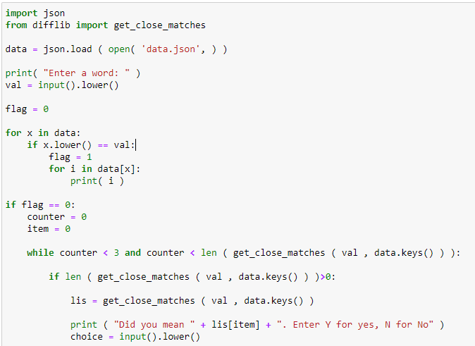

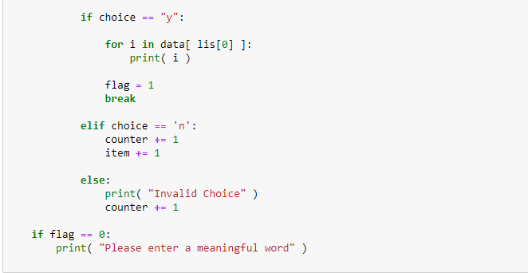

# Chapter 6

## Result & Discussion

**6.1 CASE 1: - If exact word is present in dictionary**

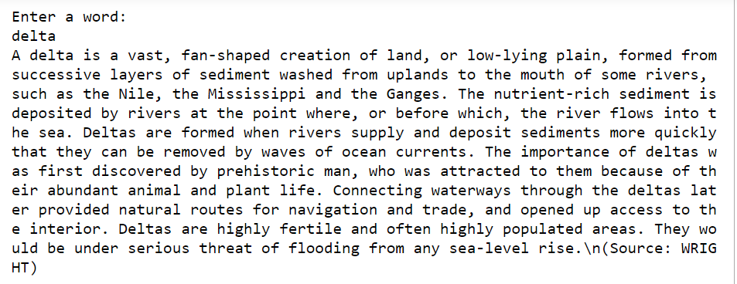

Fig 6.1

**6.2 CASE 2: -If suggested word is present in dictionary**

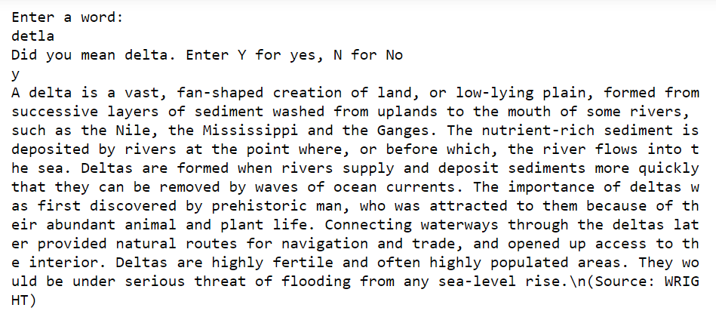

Fig 6.2

**6.3 CASE 3: -If none of the suggested words are present in the dictionary**

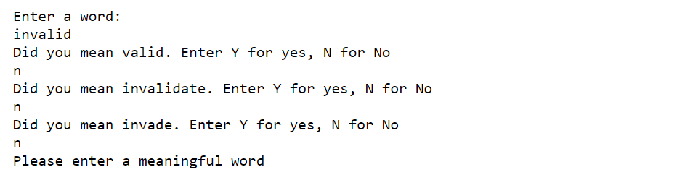

Fig 6.3

# Chapter 7

## Conclusion, Limitation & Future Scope

Our project implements functions of a dictionary which is easy to use. Dictionary is a book or electronic resource that lists the words of a language (typically in alphabetical order) and gives their meaning, or gives the equivalent words in a different language, often also providing information about pronunciation, origin, and usage.

Compared with paper dictionaries that mainly organize entries around a single word, online dictionaries allow users to access multi-words by consulting more than one component of a multi-word. Thus, users can search for a certain verb phrase as a whole to identify its meaning.

Together with the multifunction provided by online dictionaries, dictionary users can learn more about the latest revisions and new words as editors can update entry information every few months

We have made a project in python which takes a word/phrase as input from the user and searches in the stored dataset of words and their meanings. If the word is present in the database then it displays the meaning of the word/phrase. The other scenario can be the word/phrase might not have been present in the database then the code suggests similar word/phrase and asks the user whether the suggested word is the word user is searching for.

The suggestions will be provided three times to the user and after that the program will stop and display a message to provide a meaningful word.

**References**

* <https://docs.python.org/3/library/difflib.html>
* <https://www.geeksforgeeks.org/read-json-file-using-python/>
* <https://www.geeksforgeeks.org/python-find-close-matches-input-string-list/>
* <https://stackoverflow.com/questions/36283391/difflib-get-close-matches-get-score>